BASICS
NAME: Maya
RACE: Deer mice
CLASS (and archetype): Druid Spore circle
BACKGROUND: Cult member
ALIGNMENT: Lawful neutral

Species picture:

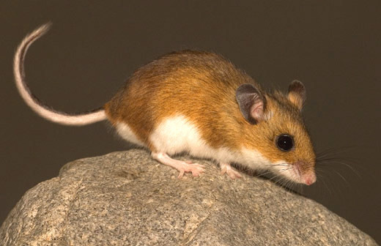

SUMMARY
Growing up in a closed group with odd ideals and morals, Maya gets separated from other members of her community when a particular rite goes awry.

NAMES AND LOCATIONS
Lain (lion’s mane mushroom), Sonia (teacher and supervisor), Rem (head director), Nora & Will (siblings), Martha (enthusiastic follower and hater)

CULT BACKSTORY – Blooming Lion
(for the dm)

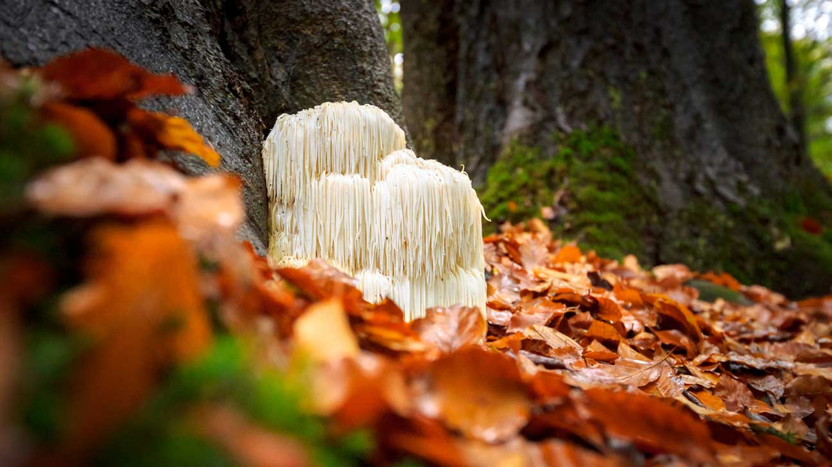

- Lain was a Lion’s mane mushroom in a colony of many, following a long-forgotten druid sage. On some now unclear memories of expeditions with him to dangerous realms, something unexpected occurred.

In a flash of light all became confusing, his consciousness separated from the rest of his colony. He got to feel the deafening silence for but a moment as next a vision appeared. A huge mouth with bigger fangs, golden eyes, a mane so radiant, the ultimate form.

Of course that was a vision of his true potential, a glimpse of the being he can ascend to and attune to greatness.

His mission set, he will use what he knows to fulfill this purpose.
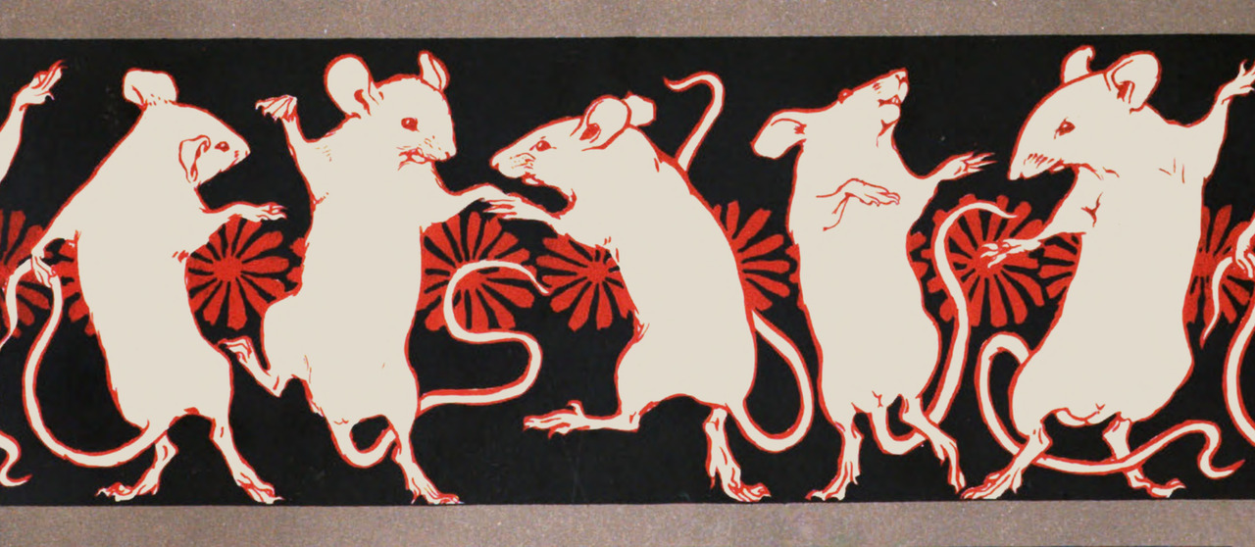

- Unassuming and meek, some would say. The truth is mice are a race with the most noble ancestry, to the great lions.

The current form is simply a trick, does the tail not fit a tuft at the end? Do these ears not make room for thick, long manes? And this mouth that can make a thunderous sound just like the late lions surely did. Or so this group believes.

Under Lain, a nest of Deer Mice is working hard to honor these convictions. They willingly offer their minds and bodies to him, making a colony of around 15 mice and fungi.

They have to work tirelessly, sacrificing autonomy and nutrients, all while searching for remnants of the great lions.

Sometimes their search changes rapidly, often leading nowhere. Surely it all has a purpose and one cannot be so shallow to believe these are failures.

Libraries of castles and hidden archives must have answers, albeit first, numbers and strength is needed.

The road ahead is long, but even as their bodies succumb to mortal death, Lain will ensure to make their purpose extend. Making them spores that will spread and one day in unison roar a Lion’s song.

EARLY LIFE

When born, all children are lumped together, direct parentage is of no significance here.
Education comes immediately, not waiting for sight or hearing to develop. Spores are introduced, they stimulate the mind and lungs. Some don’t get to continue long, instead used as sustenance for the colony and thus propelling it.

When Maya was born, it was a cold winter. Lain guided the colony far more than normal. Something unexpected happened. Foreign bacteria and viruses swept up the young of that year, including her. Many succumbed, as the spores violently fought for full “custody” in their bodies.

Maya and her siblings survived, but the process of indoctrination was left incomplete. Eager to still fit in, the children tried their best, even if sometimes it was apparent to others how lacking they were.

It was hard to attune at times to the colony’s thoughts. There were anomalies, little straying desires and thoughts.

Sonia was so kind, it hurt greatly to disappoint her. Hurt their backs and necks. It was a disservice to be such a letdown. Unlike the diligent Martha, who was older and a proper example.

Things got better though, practice bore some fruit, not enough in everyone’s eyes. But acknowledgment from Rem was enough that there is a chance to be present during the communing with Lain’s physical form. Attending to that form was of the utmost importance, but for Maya much of the details were not yet known.

Nora and Will were more rebellious, brazenly running around “Without any understanding of anything!” – Maya said.

Will was mostly angry in those moments, spouting sacrilege with his words, Nora looked at her with “not good feelings”, that’s as far as Maya ever figured out.

But that is not important, she will fulfill her duty and not be led astray by the blasphemy. She will show them and everyone else, then Nora and Will shall sit beside her at supper.

And all will be good and right.

INCITING ADVENTURING INCIDENT

- As her existence started with a storm, so did it change. During a quest to find a cave Lain said would have remnants of the old Lion civilization, the group got separated, it was impossible to keep the connection with unruly winds and deep snow.
The cult, scattered and of unknown status, left Maya to a deafening silence. She is convinced that same as Lain, what follows is something divine.
A breakthrough.

CHARACTER NOTES

PERSONALITY
Uptight, suppresses carefree impulses, edgy teenager that thinks no one outside her cult understands her.

APPEARANCE
Age: 14 in human years
Height: Small
Build: Standard mouse
Fur: Golden brown and white belly
Eyes: Dark brown
Clothes: Greenish and blueish robaes
Weapons: Quarterstaff with spiral like squiggles etched on
